
Design and Construction of Ackerman Steered Robot

Deliverable 5
EML4551

Group 14
December 4, 2008

QUINN, KYLE
SOSA, JULIO
STEEL, ROBERT
WOODS, TREVOR



Executive Summary

The project at hand called for the design of an Ackerman steered robotic vehicle. The sponsor for this project is the Center for Intelligent Systems Control and Robotics (CISCOR) here at the FAMU-FSU College of Engineering. The primary contact for CISCOR, as well as our faculty advisor, is Dr. Emmanuel Collins. Currently all of the robots used at CISCOR for controls research are based on skid steering, where direction of travel is changed by varying wheel speeds. These robots also have rigidly mounted wheels that when combined with skid steer, do not allow for rigorous all terrain travel.
To solve this problem, CISCOR tasked our group with the design and construction of an Ackerman steered robotic vehicle. The vehicle must have 4 wheel Ackerman steering. CISCOR has provided us with many of the components needed to complete the robot, including 4 Maxon motors for the individual wheels, and 2 more for the front and rear steering mechanisms. We also were provided with all of the control systems hardware, and the SICK directional laser to be mounted on the front of the vehicle. Due to the nature of the motors, the customer also specified that the vehicle must have a fully independent suspension. It was also decided that the scope of this project was to design the complete the frame, steering, suspension, and all other mechanical components necessary for vehicle travel into our design. Additionally, proper locations and mounting for all control systems must be designed. The design of the electrical system and control programming however, is not within the goals of this group, and will be added in with CISCOR’s help.
Starting with suspension, several different concepts were generated for the vehicle. The chosen design was one that implemented a double wishbone independent suspension on all 4 wheels. It was chosen based on the fact that it would provide the best performance, and could be integrated the best with all other components of the robot. Upon completion of the detailed design inclusive of all systems, analysis was done on significant systems to verify performance. A finite element analysis was done on the frame using Pro Engineer’s Mechanica module, while a complete suspension analysis was run using Adams Car software. The analyses resulted in favorable performance of our design under different stress conditions, and wheel travel. Now that the design has been completed and the performance is up to par, the spring semester can begin with ordering and manufacturing of all remaining components.
Table of Contents

Introduction 4
Problem Definition 5
Project Scope 5
Concept Generation and Selection 6
Ackerman Steering Concept 7
Concept 1 8
Concept 2 9
Concept 3 11
Concept Selection 12
Design 13
System Design Breakdown 13
Final Design 15
Design Analysis 18
Finite Element Analysis 18
Adams Car 27
Cost Analysis 32
Plans for Fabrication and Testing (Spring) 34
Acknowledgments 35
References 36
Appendix A 37

Table of Figures
Figure 1: Concept Ackerman Steering Design 7
Figure 2: 4-Wheel Ackerman Steering 8
Figure 3: MacPhearson Suspension 9
Figure 4: Trailing Arm Suspension 10
Figure 5: Trailing Arm Suspension (Bottom) 10
Figure 6: Double Wishbone Suspension 11
Figure 7: General Layout 15
Figure 8: Drive Line Close-up 16
Figure 9: Steering Linkage 17
Figure 10: Component Layout 18
Figure 11: Original Frame Design 19
Figure 12: Frame Design Using 3 Horizontal Bars 20
Figure 13: Frame Design With Front and Rear Lower Supports 21
Figure 14: Design Using Combination of Previous Designs 21
Figure 15: Material: Steel With Maximum Displacement of 0.0197" 23
Figure 16: Material - Aluminum with Maximum Displacement of 0.0539" 23
Figure 17: Additional Horizontal Support - Maximum Displacement of 0.0187" 24
Figure 18: Additional Lower Support - Maximum Displacement of 0.0191" 25
Figure 19: Combination Design - Maximum Displacement of 0.0169" 26
Figure 20: Adams - Top Right Suspension View 27
Figure 21: Adams - Front Suspension View 28
Figure 22: Adams - Front Assembly 28
Figure 23: Camber Angle 30
Figure 24: Scrub Radius 31
Figure 25: Roll Center Location 32

Introduction
Our group’s Senior Design project here at the FAMU-FSU College of Engineering is to design and construct an Ackerman steered robot. The customer and funding source is the Center for Intelligent Systems, Control, and Robotics (CISCOR) located here at the college. This product will serve as the platform for testing intelligent controls systems on and off road. Previous deliverables can be found via our group website, and can provide greater detail into the project scope.
Currently, the project is just finishing the final design stages and getting ready for fabrication. This document will serve as the control for this final stage in the design process. Before problem break down and concept generation, however, it is important to consider design specifications previously decided upon.
- 4-Wheel Ackerman Steering
- 4-Wheel Drive
- Independent Suspension
- Dry Weight (Unloaded) – 150lb
- Wheelbase 36x36”
- Ground Clearance – 4”
- Body Height 16”
- Capable of Traveling through 5”-6” of standing water
- Top Speed _ 10mph or greater
- Towing Capacity – 100lb
- Climb 30º incline
- Function for 60 minutes between charges
- Easy Assembly
- Ability to rotate on its own radius
The concepts developed were built based on the goal of achieving all of these specifications once the final product is fabricated. The problem was broken down into subsystems for more efficient generation of ideas, and problem solving. Each subsystem was approached individually, and when combined gave the different design cases from which we had to choose from. Once we decided on the design to use for the robot, we moved onto the final design, where we integrated all of the subsystems we had decided upon. A few problems were encountered while designing around the drive motors.

Problem Definition
The project was to design an autonomous robot that was Ackerman steered and integrated all of the parts that have already been purchased for use with this robot. This concept is a large improvement to the versatility of the robots currently being used by CISCOR. At the moment all of CISCOR’s robots are skid steered so this would create new opportunities for them. This robot will be much larger than the robots currently employed by CISCOR for testing but it would be more versatile than any of the other ones.

Project Scope
Currently no off the shelf robotic vehicles come equipped with Ackermann steering capability; they have skid steering, or some other form of steering that has a limited maneuverability. All of the robots currently being used by CISCOR are made using off the shelf frames and bodies, and then appropriate modifications are made in house to accomplish the tasks required. Of these off the shelf robot frames and bodies, none come equipped with Ackermann steering. Ackermann steering encompasses a linkage geometry that allows each turning wheel to trace out a different radius circle during a turn. In addition, the currently produced robots have limited terrain capabilities, partly due to steering mechanisms, ground clearance, and lack of an active suspension.
Before the design process could begin, our group did background research on current automotive designs of frames, steering, and suspension. Combined with additional research on robotic systems and their construction, and a basic design was developed. We began the design process by first creating 3-d models of the controller, batteries, and the motors. Since all of that must fit inside the body of the robot, this allowed us to begin designing a preliminary frame. Beginning with a design in Pro Engineer, the first draft for the frame was then placed into COMSOL and a finite element analysis was done. From there the design was modified accordingly based on the strength requirements for the frame. Next, attention was paid to the steering and suspension design, using Pro Engineer and Adams software. The suspension for this project was one of the hardest parts and is the most important for creating the kind of robot that the client is requesting. After the mechanical systems of the vehicle were finalized, the electrical and computer systems were integrated into the design.
We expect to have our parts ordered before the end of the fall semester. The vehicle will be built and functional by April of 2009, prior to the end of the spring semester. The vehicle should achieve all the objectives listed above, and will contain the following basic equipment to do so; 2 Maxon DC Motors, 4 Maxon EC Motors, a compatible Maxon motor controller for each, an Avantech Computing System, 2 Data Acquisition Sensors, a Tri-M Power Supply, 3 Lithium Powered Rechargeable Battery Packs, and a SICK Laser measurement Sensor.
Investment risks are minimal for CISCOR because of their role as a research facility. Part of research and development includes the possibility of monetary loss through product failure and design flaws. As a group, it is our job to limit the possibilities of such failures. The benefits of a quality finished product include functionality in all-terrain settings for CISCOR. In addition, the fact that a product of this nature does not already exist leaves CISCOR open to develop and sell the design for mass production if they wish to do so.
Trade off will have to be made between power and speed; in addition size will play a role in the overall maneuverability. With the current basic hardware listed above, the finished product already seems as if it will be the size of a small go-cart.

Concept Generation and Selection
Since the steering for the robot has already been set as Ackerman steering, the component which we had the most control over was the suspension. The customer requested that the robot have 4-wheel independent suspension so we took a lot of the time to look into different suspensions.

Ackerman Steering Concept
Since there is really only one way to do Ackerman steering, we decided to go with a basic conceptual design until the suspension and frame had been finalized. This way we would know exactly where the motors would be positioned and we would have a much better idea of where we could connect the linkages. During the design process we made sure to leave room around the steering motors to allow movement of the linkages.
Commercially developed Ackerman steering utilizes a spindle at each of the front wheels that pivot about a king pin. Each spindle is connected to each other through the use of tie rods and a rack and pinion. The linkages connecting the spindles form a trapezoid (Figure 3) and thus allow each spindle to follow a different radius, depending on if it is the inside or outside wheel. The difference in the radii accounts for the outside wheel traveling farther than the inside. The draw back of this system is that it is only accurate in three positions throughout its range of motion (straight ahead and one position in either direction). It is, however, required for this project as well as the best choice for our steering design.

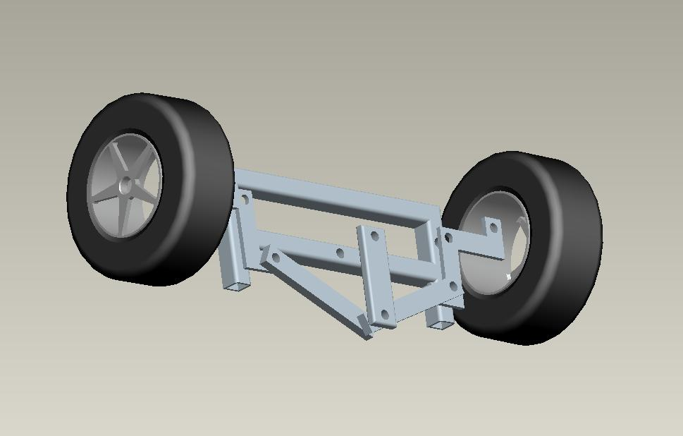
Figure 1: Concept Ackerman Steering Design

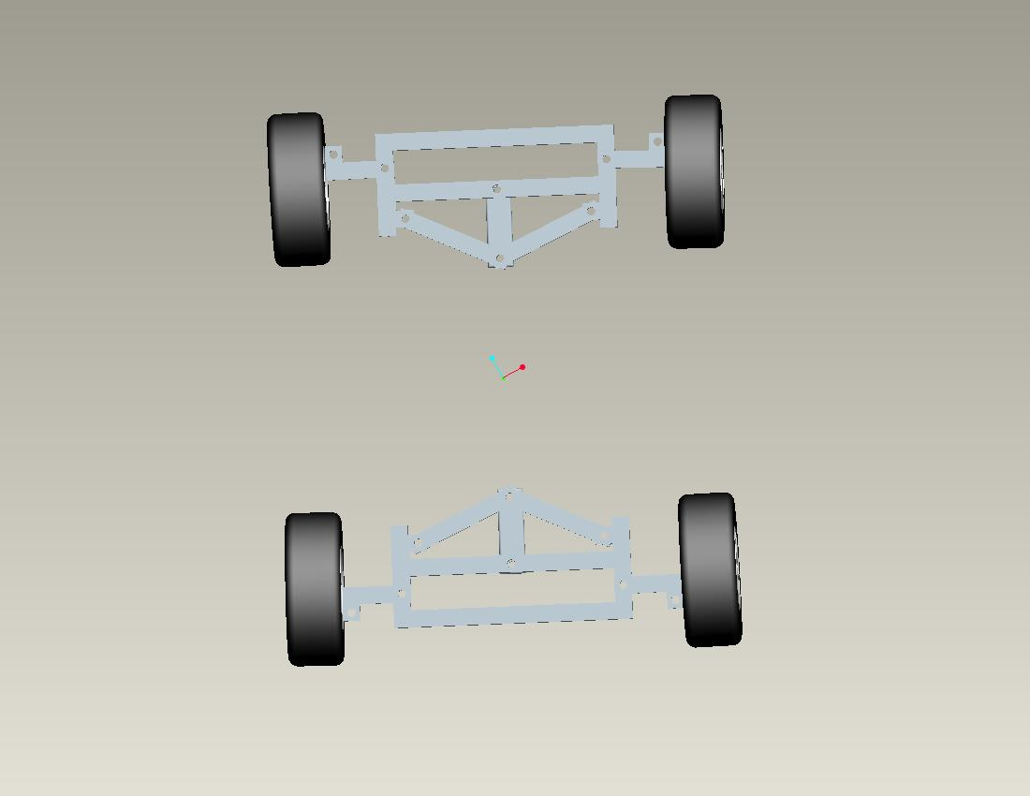
Figure 2: 4-Wheel Ackerman Steering

The design shown above was built on the premise that each pair of wheels will have its own steering motor. Because of this, there need not be any linkage traveling the length of the vehicle to link the steering (Figure 4). Furthermore, each steering motor will be computer controlled (programming provided by CISCOR), and will transfer motion to the crankshaft centered between each wheel at both the front and rear.

Concept 1
The first concept we looked at for suspension was a MacPhearson suspension. This setup consists of a strut connected to a lower control arm, and both the strut and control arm are connected to the frame. This type of suspension requires minimal side to side space, but because the strut is the upper link of the system, it requires a larger amount of vertical space, thus limiting us in the height of the robot (Figure 5). Other advantages include fewer parts which translate to lower cost, and ease of adjustment for the ground clearance of the vehicle.
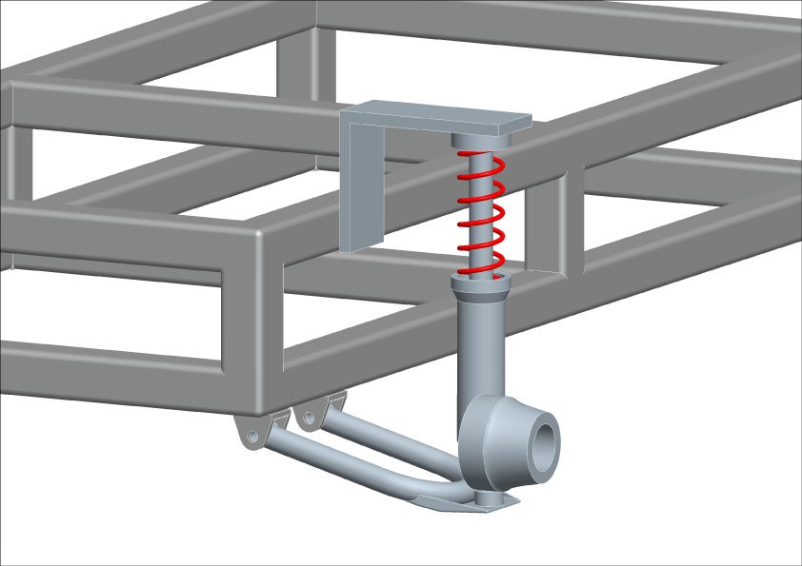
Figure 3: MacPhearson Suspension

Concept 2
The second concept we looked into was a trailing arm suspension. A trailing arm suspension is usually used in the rear of the vehicle. The pivot axes of the control arms are perpendicular to the longitudinal axis of the vehicle. This type of suspension is normally used exclusively on the rear of vehicles, however it can be adapted to work on the front (Figure 7). It is advantageous if we are trying to minimize the track width of the robot because the suspension does not stick out as far as other types. However, it does require a large amount of lateral space to accommodate the trailing arms.

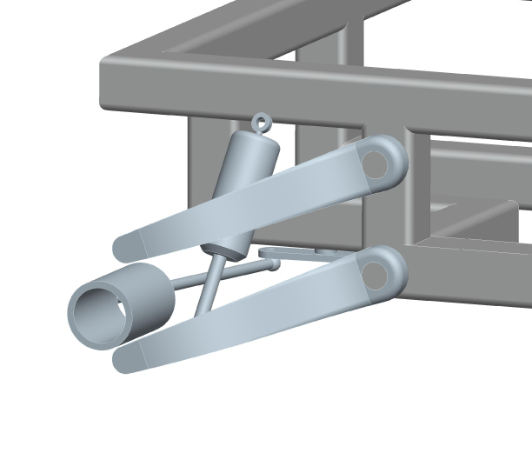
Figure 4: Trailing Arm Suspension
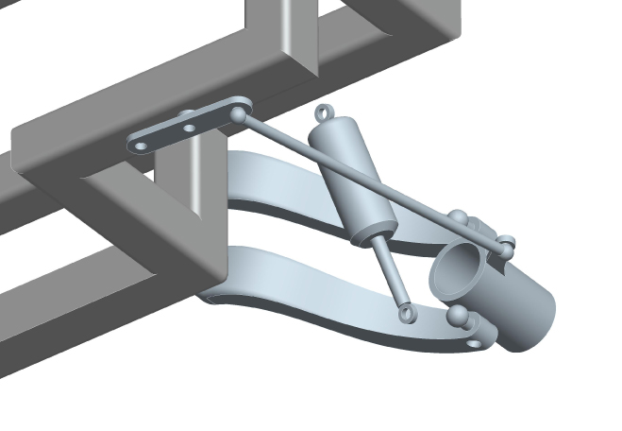
Figure 5: Trailing Arm Suspension (Bottom)

The trailing arm concept also requires modification of the rectangular frame of which the other concepts have been built on. The lower level of the frame has been taken inward at the corners to create space for the mounting of the spring/damper assembly inside the trailing arms, and underneath the frame (Figure 8). This creates additional space to route drive train, and more importantly steering linkage.

Concept 3
The final concept that we looked into was a double wishbone suspension. A double wishbone suspension is the most common suspension system for front mounted engine, rear wheel drive cars and trucks since WWII. This type of suspension may be used on both the front and rear of the robot. The systems initially had equal length upper and lower control arms, to minimize the amount of camber change in the suspension travel. However modern applications use shorter upper control arms (Figure 6).

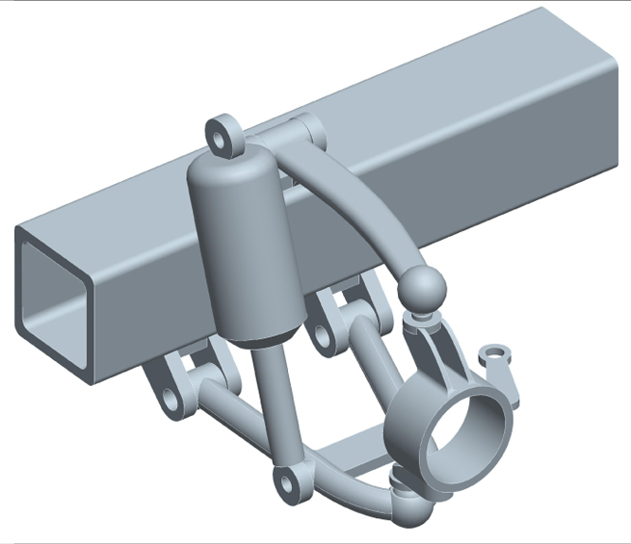
Figure 6: Double Wishbone Suspension

By changing the length of the arms we can control the cornering characteristics of the robot, which will be necessary to keep the robot steady through a high speed turn. More importantly, we must consider the goal of off-road capabilities for the product, and the correctly designed double wishbone suspension can result in more suspension travel than any other set up. This type of suspension is easy to duplicate and very common.

Concept Selection
Before choosing a concept it was important that as a group we considered some facts. First off, the steering design is not up for debate, therefore it was not considered in the decision matrix. Secondly, frames are dependent on the suspension design. This means that for our decision matrix, we only considered each of the three suspension design cases generated. For any product, a decision matrix can be very short, or infinitely long. As a group we discussed the important attributes of the suspension, from which we narrowed down the important aspects for the decision matrix
The vertical and lateral spacing of the suspension are the spaces between control arms, and the length of the overall suspension set-up. The increase in width, accounts for the additional width added to the vehicle, from the edge of the frame, to the tire footprint. These are critical components in our final products dimension specifications. For performance, the qualities we rated were speed, off road capability, and ride stability. This directly relates to the primary function of the product as an all terrain vehicle, and how its performance affects the components which will be integrated into the body of the robot. Finally, manufacturing price, parts availability, and fabrication were taken into consideration. For the purposes of concept selection, price refers to the raw materials necessary to construct the frame; and if we are unable to find correctly sized off the shelf suspension components, it includes the price of material for suspension fabrication. This plays into the availability of parts and number we have to choose from, and is directly related to fabrication difficulty, and time.
Each attribute was given a weight of importance based on the consensus of the group. Additionally, each concept was scored on how closely each individual attribute met and/or could be designed to meet product specifications. When multiplied by the weight factor, the result was a final score for each case from which we based our final selection decision from.

Table 1: Decision Matrix
 |  | Option 1 |  | Option 2 |  | Option 3
Attributes | Weights | MacPherson |  | Double Wishbone |  | Trailing arm
 |  | Value (1-10) | Weighted | Value (1-10) | Weighted | Value (1-10) | Weighted
Size
Vertical Spacing | 8 | 7 | 56 | 5 | 40 | 4 | 32
Lateral Spacing | 6 | 2 | 12 | 5 | 30 | 6 | 36
Increase in width | 5 | 5 | 25 | 8 | 40 | 2 | 10
Performance
High Speeds | 4 | 7 | 28 | 8 | 32 | 7 | 28
Off Road | 8 | 3 | 24 | 9 | 72 | 5 | 40
Stability | 9 | 6 | 54 | 8 | 72 | 5 | 45
Manufacturing
Price | 8 | 8 | 64 | 6 | 48 | 7 | 56
Parts Availability | 9 | 7 | 63 | 5 | 45 | 3 | 27
Fabrication | 8 | 7 | 56 | 5 | 40 | 3 | 24
Total |  |  | 382 |  | 419 |  | 298

The results from the decision matrix were a high score for the double wishbone suspension concept, followed closely by the Macpherson. The attributes where the double wishbone excelled were the increase in wheelbase, and all around performance. Although the Macpherson suspension actually scored higher in the manufacturing section, its inferiority in the other two sections outweighed those advantages. The trailing arm option, although a solid design, was not a viable option for this product when compared to the better performing technologies.

Design

System Design Breakdown
General
The robot as a whole will need to integrate many components in order to achieve full autonomy. Because of this, our design must not only integrate the vehicle components concerning drive train and suspension, but must also encompass all electronic systems, controllers, and other equipment necessary for operation. Many of these items, as stated before, have been provided by CISCOR, and a full inventory can be found in Deliverable 3. The general layout of the final product will need to provide adequate space for each component, and be easily disassembled for maintenance and future upgrades. Additionally, the product will have to meet preliminary design specifications as closely as possible.

Ackerman Steering
Our primary goal, as well as the only non-negotiable vehicle system, Ackerman steering provides the base for all of our concept generations. Per request of the customer, we will be implementing a 4-wheel steering system, with an individually controlled motor for each pair of wheels, front and rear. The result should be a design that can be mirrored from the front to rear of the vehicle. Since this vehicle is intended for off road use, special attention must be given to the ground clearance in the steering linkage. In addition, the joints that create the mechanism must work in such a fashion that they will not shear or otherwise fail due to the stress of all-terrain travel. However, these are detailed design considerations, and for the purposes of concept generation, we needed only consider the mechanism design. A working 4-wheel steering model will be the best way to conceptually integrate this specification into the robot. However, Ackerman steering is, and will continue to be the only option for steering design, by customer request.

Frame
Frame design is important for a number of reasons. First off, it provides a structure from which all components have a connection to, either direct or in-direct. Also, when combined with suspension design, is the basis for vehicle rigidity and ride. The frame must be constructed in such a fashion that it works in conjunction with suspension. More importantly for our product, care must be taken to make sure the frame does not interfere with the Ackerman steering design.

Suspension
From a suspension standpoint, comfort is not an issue since the product is an autonomous robot. Ride, however, is still important due to the fact that a rigid vehicle would transfer vibrations and all other loads directly to any attached components. In addition, a good suspension design will aid the vehicle with more efficient travel through the rough terrain planned for. As stated before, the suspension and the frame work hand in hand; so much so in fact, that each suspension concept has been paired to a particular frame, so as to verify that components are of best fit. Due to our 4-wheel drive and steering requirement, and our lack of standard drive axles, the suspension cases must all be based on independent suspension designs in both the front and rear. In generating suspension and frame combinations, we have taken into account how we will be able to meet product specifications during final design.

Final Design
The final design for the Ackerman steered robotic vehicles incorporates the double wishbone suspension decided upon during concept selection, combined with a rack and pinion Ackerman steering setup. Because of the 4 wheel drive and steering requirement, we were able to use the same design for both the front and rear of the vehicle as can be seen in the figure below.

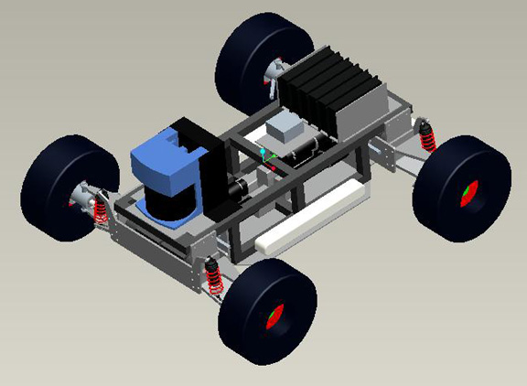
Figure 7: General Layout
Special Attention should be made to the layout of the motors. To reduce the track with of the vehicles the motors were mounted lengthwise along the frame. Right angle planetary gear heads were incorporated to connect the motors to each individual wheel through the use of telescoping double u-jointed drive shafts.

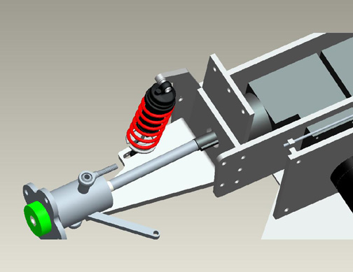
Figure 8: Drive Line Close-up

The steering motor sits above the drive motors, and actuates steering through a rack and pinion set. In addition to the gear set, steering linkage is comprise of threaded rod and tie rod ends all available through McMaster Carr supplier.

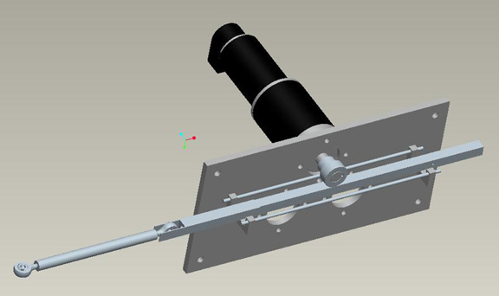
Figure 9: Steering Linkage

The final aspect of this design lies in the placement of control systems and sensor equipment. The largest piece is the SICK laser; which is the primary sensor for maneuvering autonomously through the terrain. It is mounted at the front of the vehicle to get the greatest sensor range. To offset the weight of the SICK laser, all other control hardware is placed neatly in a custom rack at the rear of the vehicle. The batteries are placed at different locations along the side and rear of the vehicle. We plan to achieve a 50/50 weight distribution with this final design. Should this become an issue during assembly and testing, the use of counterweights and replacement springs will be required.

Figure () Component Layout
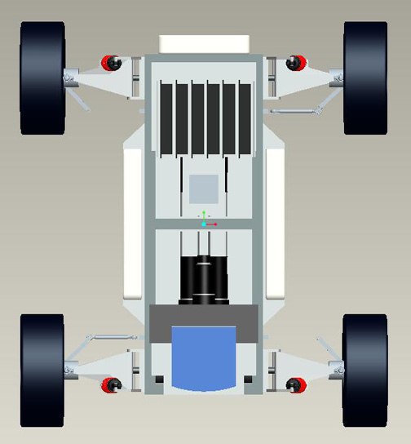
Figure 10: Component Layout

Design Analysis

Finite Element Analysis
The frame of any mobile vehicle is the most critical part of the entire system. Without the frame, there would be nothing to attach parts to. Because this piece is the sole mounting location for all of the accessories, it has to be strong and be able to withstand large forces with minimal deflection. The frame was modeled in Pro-Engineer and then analyzed using Mechanica, the finite element software that comes with the Wildfire package. These analyses were looked at and compared with one another to determine the quality of the frame design.

Structure and Description of the Frame Designs
The frame is relatively small, a mere 6” high by 9” wide by 20” long. It will be constructed of 1” by 1” square tubing with a wall thickness of 0.125”. The analysis will look at using either steel or aluminum extrusions. The aluminum would provide significant weight savings, but may not be strong enough to withstand the forces that the robot is expected to experience.
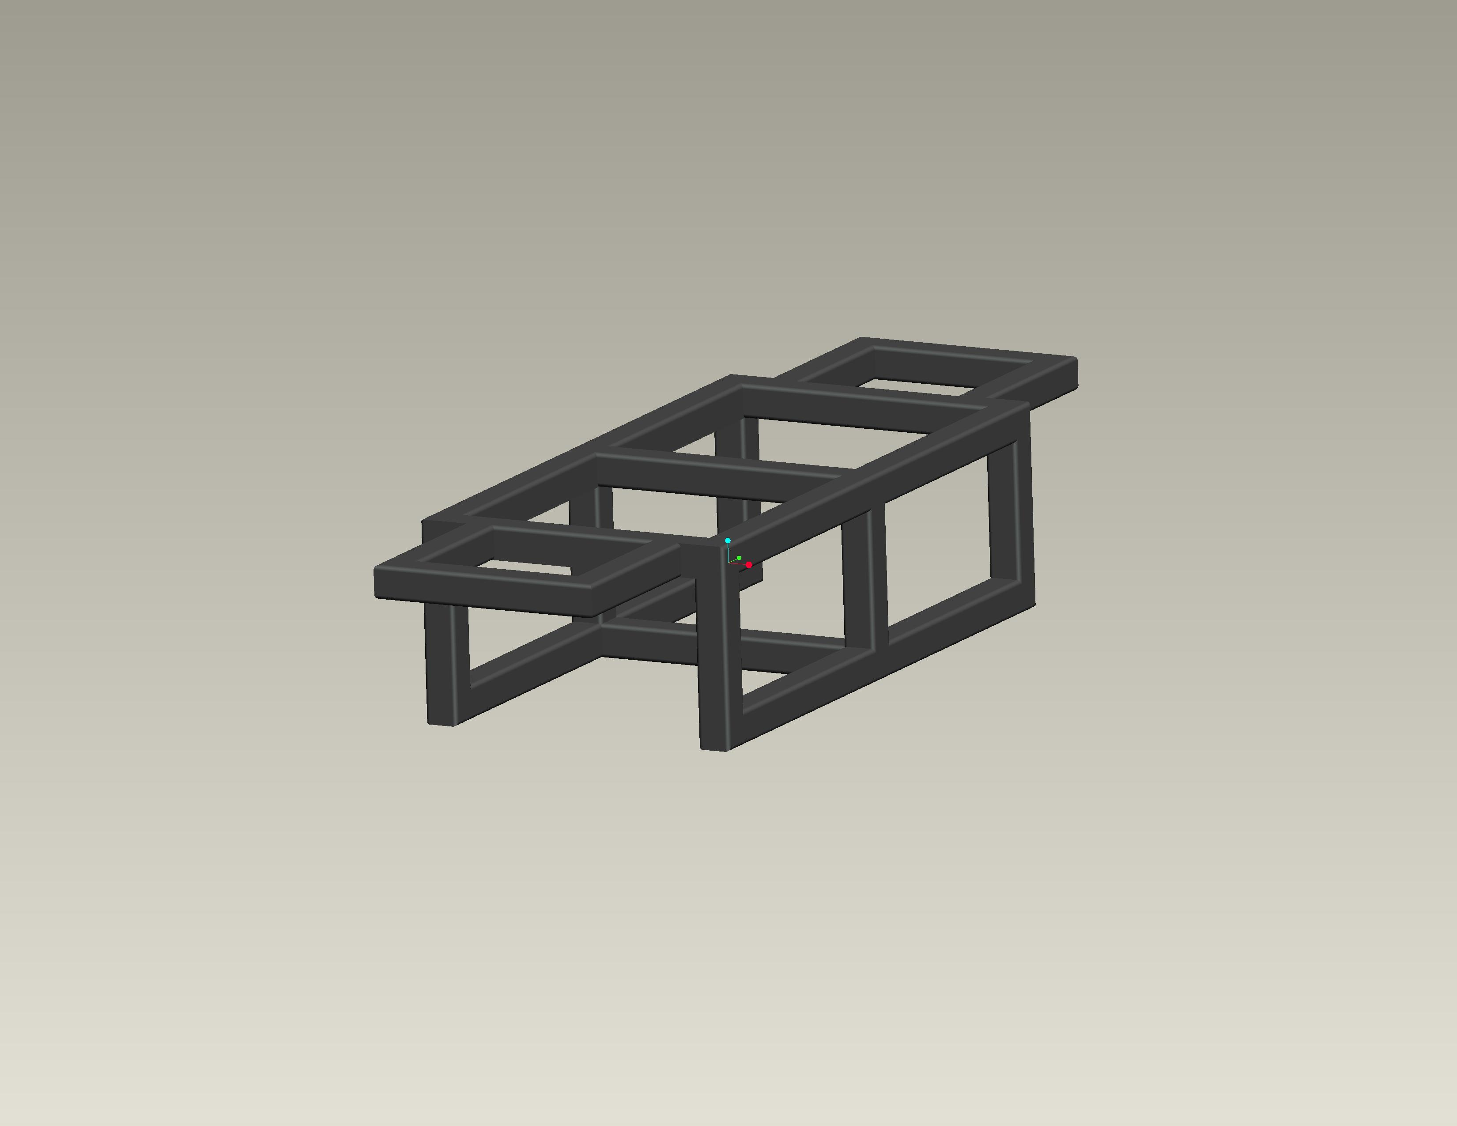
Figure 11: Original Frame Design

The frame has been purposely designed to be symmetrical. The robot will have front and rear steering, so the symmetry means that only one suspension and drive systems needs to be designed. It also allows for an easier analysis.
The analyses were run using only half of the frame. The frame was cut down the middle and the cut surface was constrained from moving while an edge load of magnitude 200 lbs was placed where the suspension will connect and a load of magnitude 500 lbs was placed on the leading surface to simulate a run in with an unknown object.

Theoretical Analysis of the Robotic Frame
Adding additional supports to the frame stiffen the frame up. The additional supports add material, and thus add strength. By adjusting the mounting locations and the number of additional supports the stiffness of the frame can be changed.
By observing how the frame will be used and where the stresses and forces will be impacting the frame, a location for the additional supports can be decided upon. By adding in a support in an area affected by stresses, one can successfully strengthen that area by giving the stress more area to dissipate into. Additional supports were added to the frame as necessary, as each analysis was successfully run and analyzed.
The first design analyzed was a cantilevered design (Figure 11). This allowed the front and rear suspension to be designed as a stand alone unit, and thus making it easier to have an interchangeable part system front to rear.
The second design considered for use was a design in which an additional longitudinal support is added to the top part of the frame only, as shown in figure 12 below. The theory was that the extra support will act as a spring and resist the forces exerted on the frame by the suspension cycling. With this design there are 5 springs acting in parallel with each other resisting the applied moment.
The third frame design that was analyzed was constructed of a support member spanning the front and rear of the frame on lower side of the frame, as shown in figure 13. This will give added support along the front and rear edges as well as help the frame keep its shape during any impact. By boxing in the front and rear sides of the frame, resistance to racking is increased and helps to keep the box shape of the object.

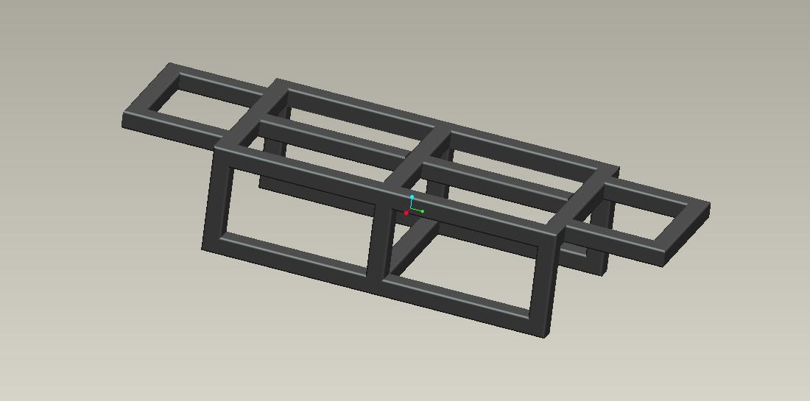
Figure 12: Frame Design Using 3 Horizontal Bars
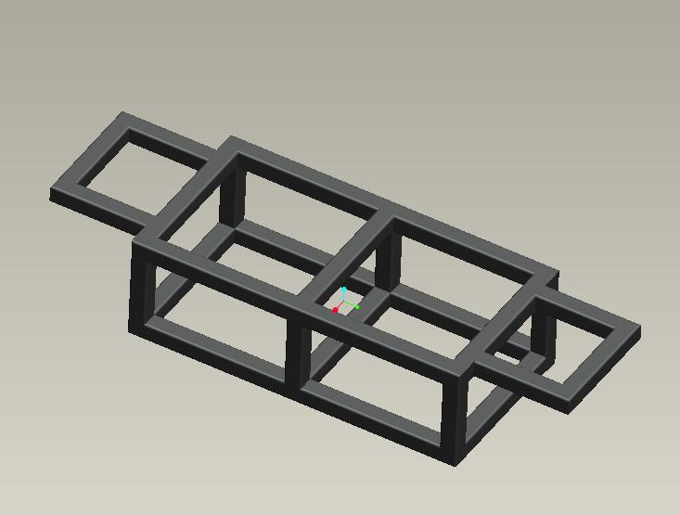
Figure 13: Frame Design With Front and Rear Lower Supports

The final design was a combination between the previous two, incorporating both the lower support and the middle horizontal support.

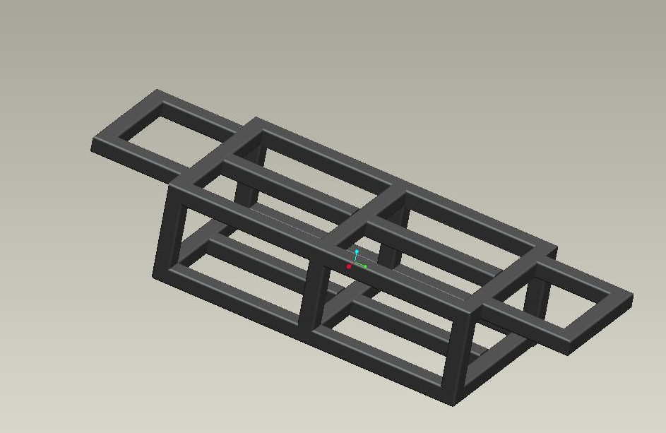
Figure 14: Design Using Combination of Previous Designs

Finite Element Analysis of the Robotic Frame Using Pro/ENGINEER Mechanica
Utilizing a finite element package imbedded within Pro/ENGINEER, known as Mechanica, the nodal deflections were determined. The results that are being compared all have the same shape and dimensions.
Mechanica allows users to “obtain real-world performance data by directly applying conditions to design geometry without requiring data translation” with “fast, automatic solution convergence, mapped precisely to underlying CAD geometry [utilizing] 3rd party solver output,” (Pro/ENGINEER Mechanica – PTC.com).
A base run was performed on the cantilevered design. This was done to obtain a data set from which to compare the other analyses to. Two materials, as stated before, are being tested, standard steel and Aluminum 2014. The physical properties of both materials are given in the following tables; these values have been taken from the Pro/ENGINEER material library.

Table 2: Physical Properties of Materials Tested
Physical properties assigned to steel within the Pro/ENGINEER software package.
Steel
Poisson’s Ratio 0.27
Density 0.283 lbm/in^3
Young’s Modulus 2.9e7 psi

Physical properties assigned to aluminum within the Pro/ENGINEER software package.
Aluminum 2014
Poisson’s Ratio 0.33
Density 0.1 lbm/in^3
Young’s Modulus 1.06e7 psi

The results of the first tests are shown below in the following figures. A wire frame depiction of the un-deformed frame has been overlaid in the analysis to show the form of the deformation in the frame.

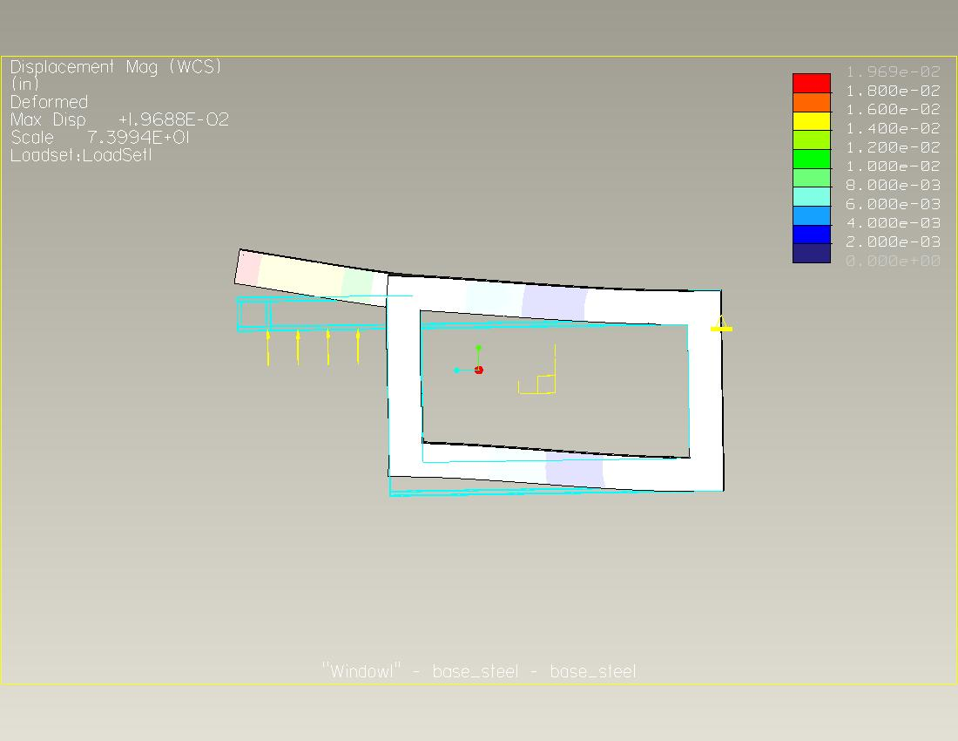
Figure 15: Material: Steel With Maximum Displacement of 0.0197"
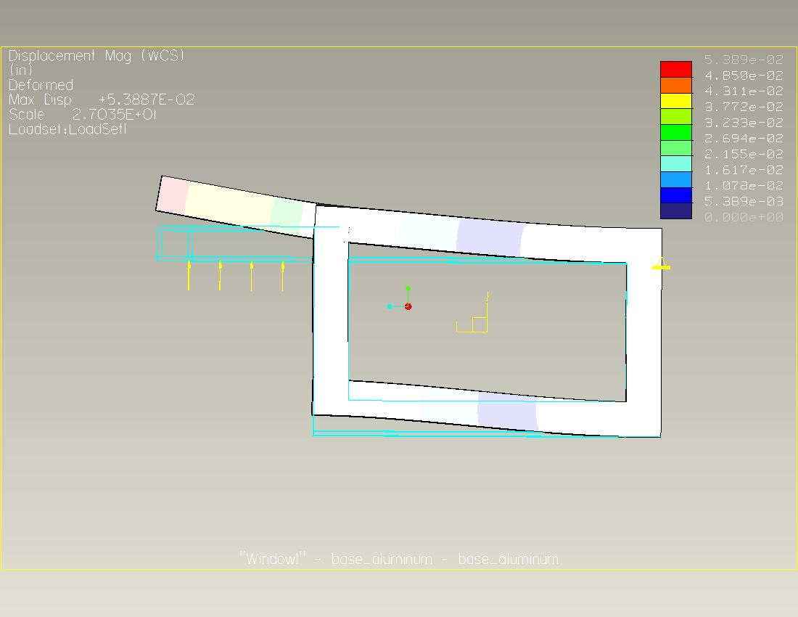
Figure 16: Material - Aluminum with Maximum Displacement of 0.0539"

The results show that the material makes a significant difference in the amount of deflection the frame allows under the given loadings. The analysis, no matter the material, shows that each frame reacts the same, and distributes the deformation in similar fashions. Further analysis will be conducted with one material, and will be compared to the base analysis.
The second analysis was run using the second design, incorporating the additional horizontal support. The additional horizontal support will allow for a better distribution of the force and help to resist the deflections.

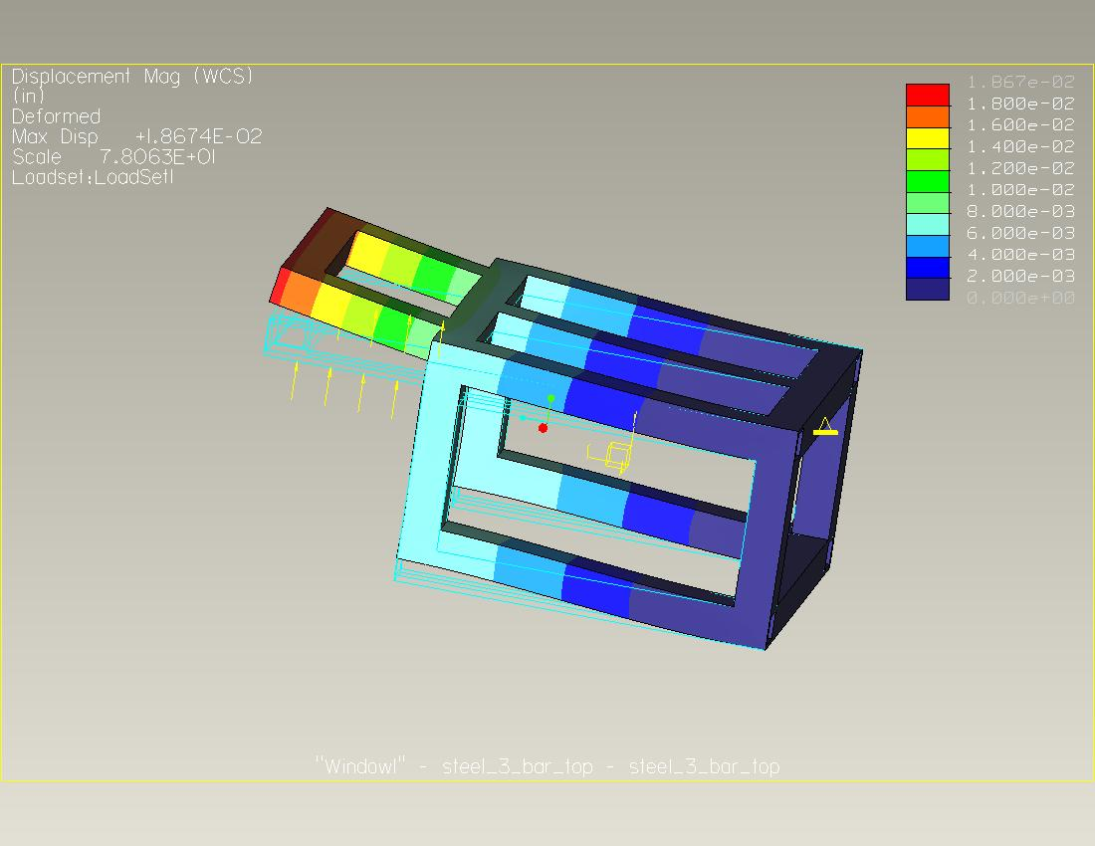
Figure 17: Additional Horizontal Support - Maximum Displacement of 0.0187"

A 5% change in deflection was seen with the additional supports placed horizontally along the top part of the frame. These supports acted as springs and caused the force to limit its effect on the deformation of the frame.
The next design used in testing utilizes an additional support on the lower side of the frame, giving it a more boxed in design. This should help to keep the frame from deforming, and will resisting any racking effects that may be incurred. The results of the analysis are shown in the following figure

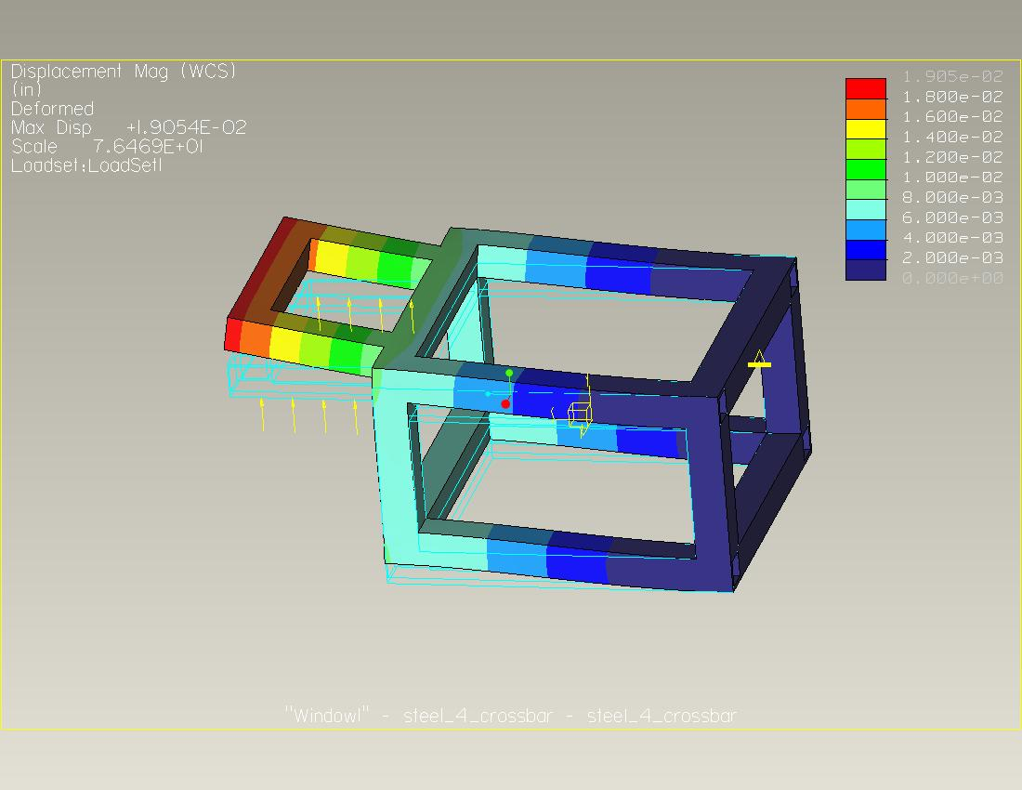
Figure 18: Additional Lower Support - Maximum Displacement of 0.0191"

The effect of this added support is less than the previous test at a mere 3% reduction in deflection. This small change shows that a support added to the bottom of this frame in an attempt to create a box shape is not as effective as the addition of a support on the top of the frame. The lower support does not provide resistance to the force exerted on the frame by the suspension components, and will only aid in the resistance to a forced placed on the side of the frame.
The final analysis was performed on the fourth frame design iteration, combining both the horizontal support and the boxed in frame. The results of the analysis is shown in the following figure

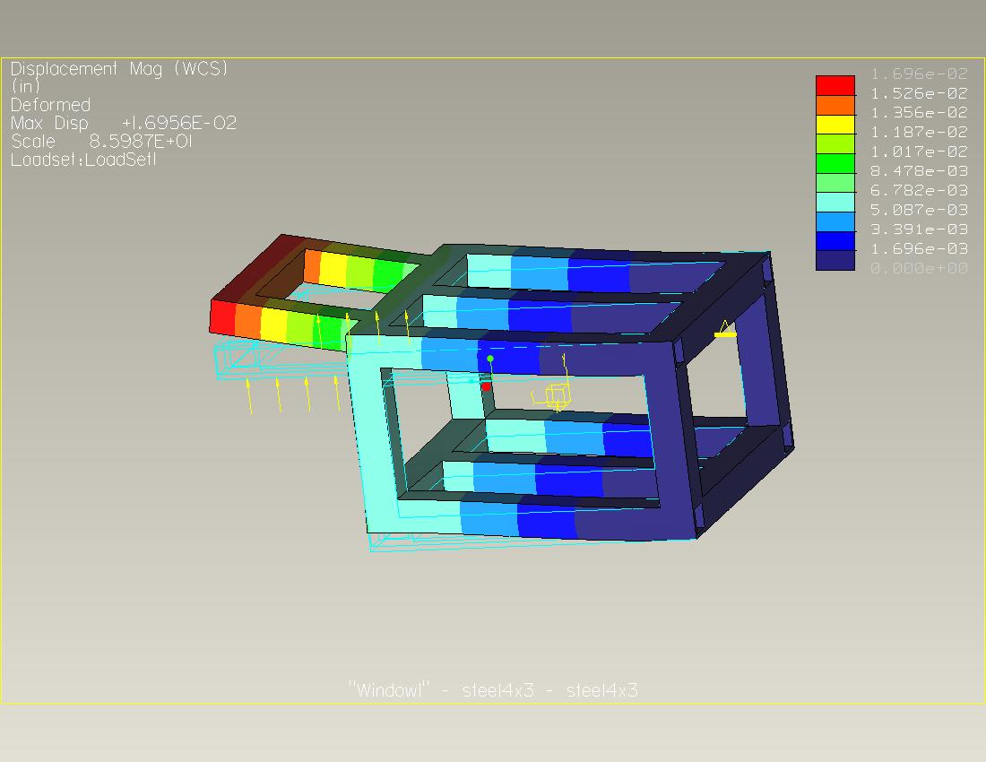
Figure 19: Combination Design - Maximum Displacement of 0.0169"

The final results of this analysis produced a reduction in deflection of 13%. The additional horizontal supports on both the top and bottom of the frame create a support structure that keeps the frame from deflecting the best. Compared to the original design, this one provides the most support. It combines the resistance to the vertical components of the forces by acting like a spring with an applied moment.
The material choice makes a much more significant change in the amount of deflection. Steel proves to be roughly 63% stiffer over the aluminum. The weight savings of the aluminum tubing is not enough to justify its use as the fabricated material of choice.

FEA Summary
The addition of supports to this robotic frame helped to increase the stiffness of the frame. This would not only help in allowing the vehicle to perform its job to the best of its ability but also to allow for a long life. The analyses performed show that increasing ones stiffness and keeping the forces the same, the deflections are decreased because the same force has more material to deform. After analyzing the results and comparing the advantages of the stiffness increase and the increase in the weight and complexity. A decision has been made to remain with the cantilevered frame design. The small deflections are not large enough to cause concern as the robot goes through its functions.

Adams Car
To analyze the suspension performance of our robotic vehicle Adams software was used. The Adams Car module comes preinstalled with templates for suspension and steering assemblies. Using the double wishbone template available, we created a model within Adams to test and record different aspects of vehicle performance. Additionally, a rack and pinion template was used to simulate steering linkage. The template themselves are modified using “hardpoints”, which are defined as the 3 dimensional positions of certain assembly points based on a global origin. After hardpoints were modified, an assembly was created and tested based on vehicle parameters.

Suspension Models

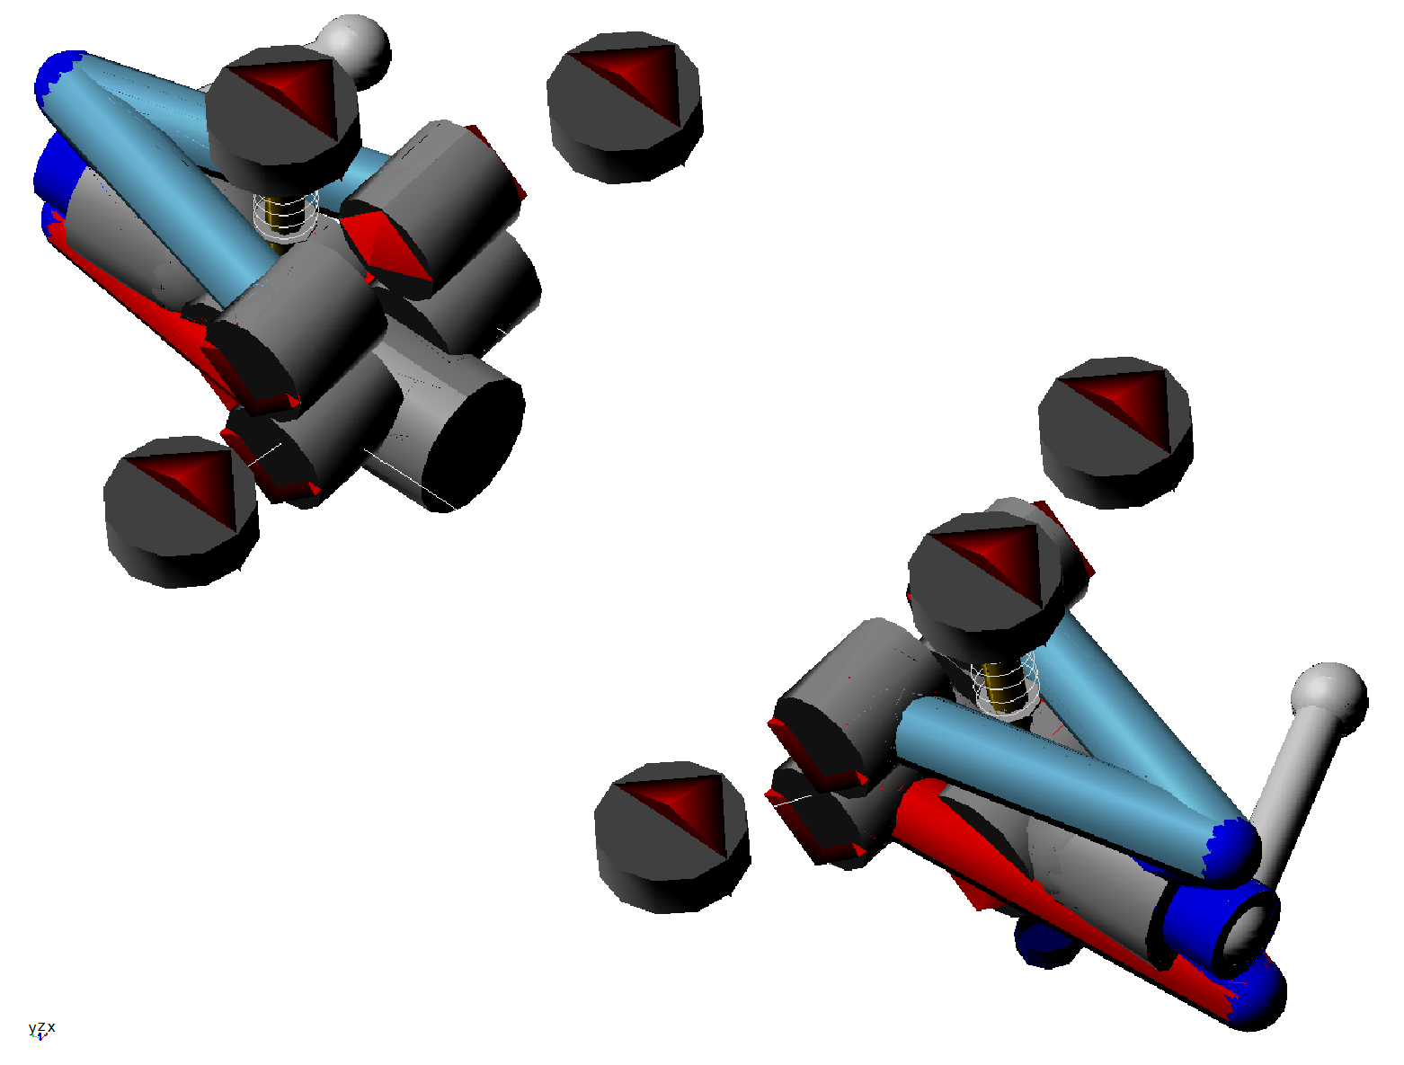
Figure 20: Adams - Top Right Suspension View

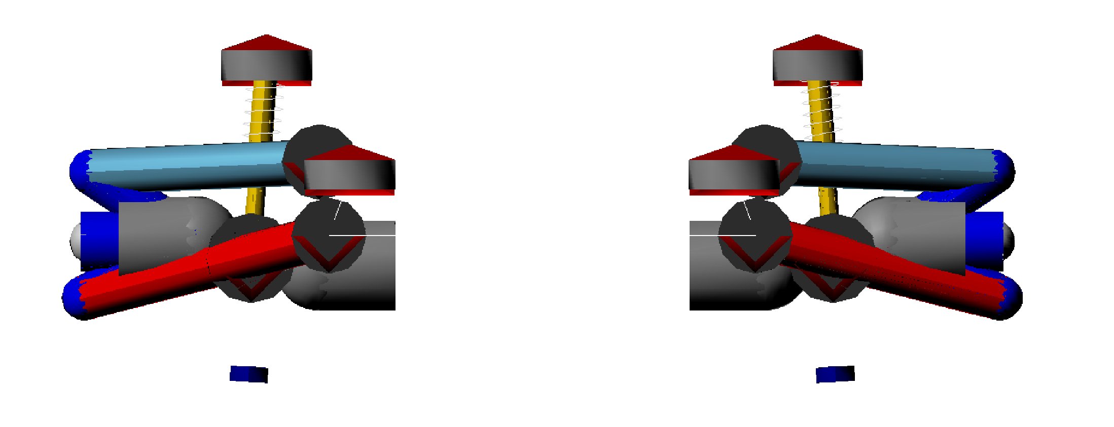
Figure 21: Adams - Front Suspension View

To perform the analysis an assembly was created using both the suspension model shown above and an additional steering model. Although we will not be using rack and pinion steering, for the purpose of the analysis it serves as a suitable modeling tool. The following figure shows the assembly of suspension components with the steering rack, as well as wheels, and ground that were utilized during the analysis.

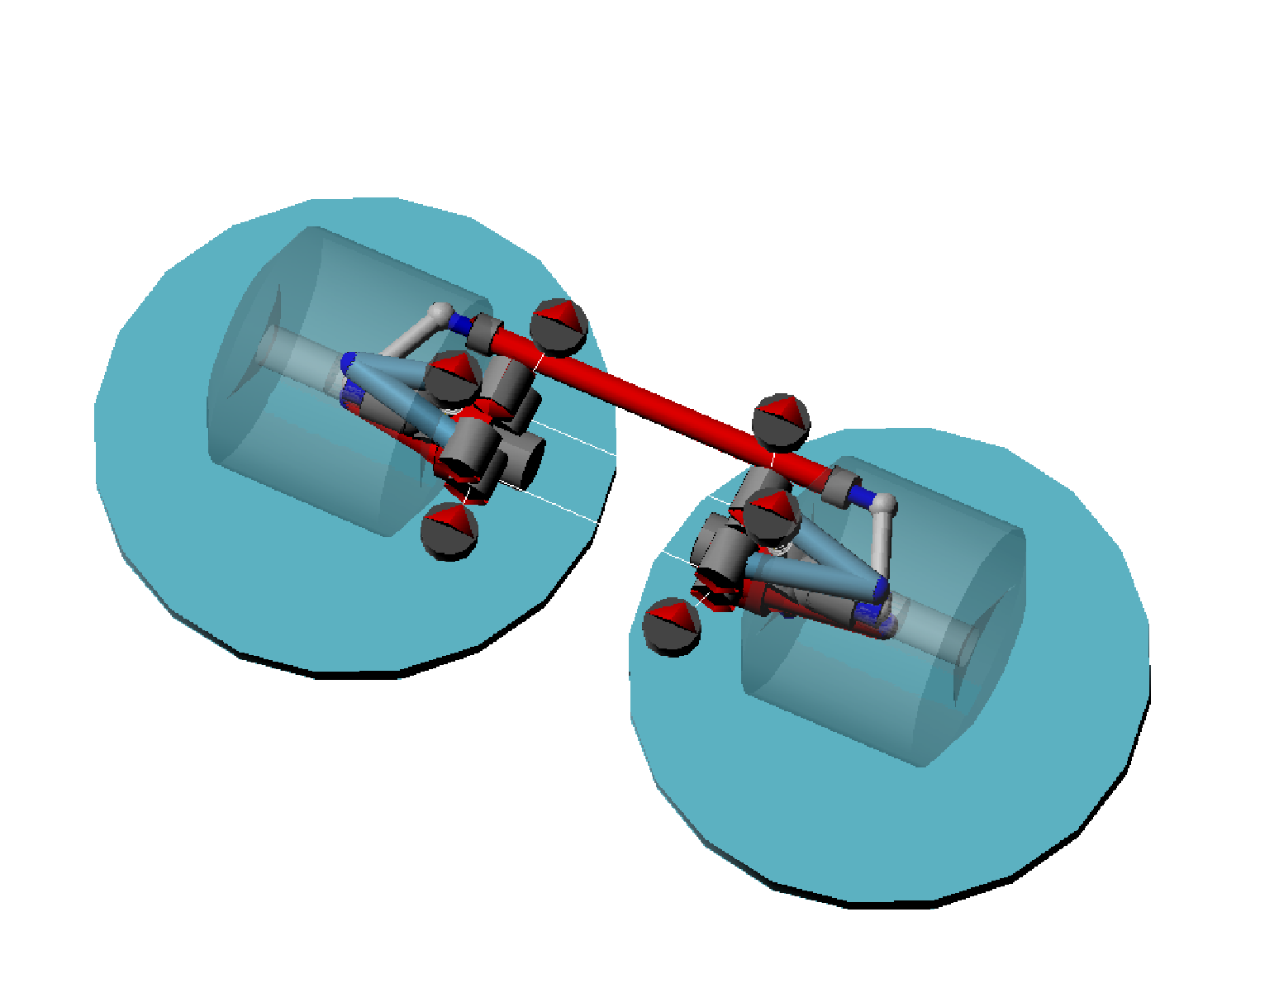
Figure 22: Adams - Front Assembly

The important setup parameters to note for this assembly were based on design specifications as well as current design. Required input included the following…

Tire Unloaded Radius | 5.25 in
Wheel Mass | 2.25 lbm
Sprung Mass | 150 lbm
CG Height | 12 in
Wheelbase | 30 in
Drive Ratio | 50/50
Brake Ratio | 50/50
Suspension Position | Front

Analysis
The suspension analysis was done simulating parallel wheel travel. The suspension travel was constrained to 2 inches, 1 in each direction, which will be sufficient for the environment our robot will be used in. The software automatically outputs a number of very detailed graphs that give insight into the vehicles performance. For the scope of what we need, however, we will only take a look at a few.

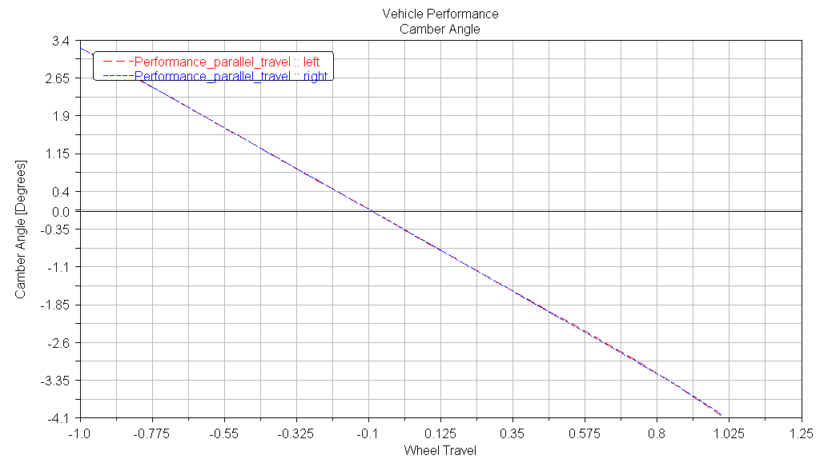
Figure 23: Camber Angle

The camber angle of the wheels is the angle created by the wheel centerline and the ground from front view. Under high performance conditions camber can be beneficial, however for our purposes, it is not necessary. We therefore designed our vehicle with the intent of having zero static camber. The resultant graph shows, however, that at zero wheel travel there is in fact a small camber angle. This was expected because of the suspension compression under static loading. The value is still very small, and can be considered a design victory in terms of reaching our goal. During wheel travel the angle increases but only to a maximum of 3 degrees. Considering the analysis ran between 2 inches of wheel travel, and our robot will most likely not, this can also be viewed as a success. To expect no camber change during wheel travel would be unrealistic, and would require a solid suspension; which was not our intention during design.

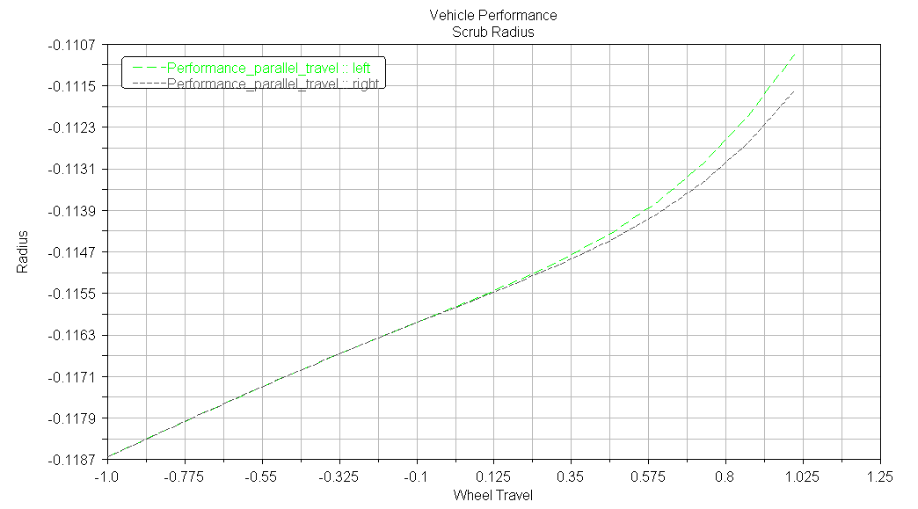
Figure 24: Scrub Radius

During wheel travel, the contact patch rotates about an imaginary circle, whose radius is referred to as scrub. The effects of scrub are such that as the suspension moves; the tires are pushed outward relative to the frame, and back in during rebound. Although a normal occurrence, scrub can become an issue for traction if not accounted for. Much like camber, the ideal result of our design was zero scrub. It is a common occurrence however, that through iterations of a design, some details change slightly. What can be seen above is that scrub did not remain zero. It is however very small, only a tenth of an inch. This proves that although designed at zero, ideal conditions are not always met. To restate, the maximum value is still very small, and is not effectively large enough to inhibit traction.

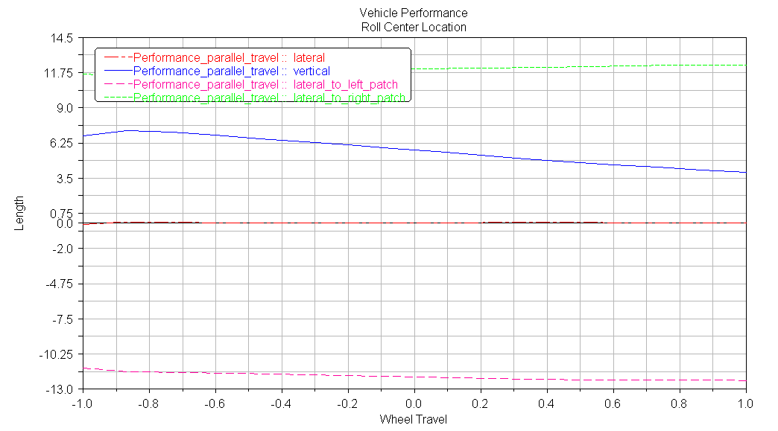
Figure 25: Roll Center Location

The roll center for the scope of this analysis was the vertical height about which the body of the vehicle rotates during suspension travel. From the graph above the important trend line to note is the vertical. During design, the roll center was picked to be 5 inches from the ground. At zero wheel travel, the value is approximately the same as what was designed for. There is a slight change during travel, but nothing drastic enough to adversely affect the performance of the vehicle. This shift can be described as normal for the vehicle motion endured.
Overall the Adams Car model served the purpose of quality control. The ideal design was input into a real performance analysis, and was verified. The suspension design for the Ackerman steered robot has met the goals set forth during design, and when fully built, will function well with the entire robotic assembly.

Cost Analysis
Since CISCOR has graciously provided us with a lot of the expensive equipment that we would have needed to order for this robot, such as the motors, controllers, and computer, the most expensive part we will be buying for the robot are the 90 degree gearheads. At around $550 a piece they easily put us well over the schools budgets for projects, but since CISCOR is providing the funding for the project, this was the price they already knew they would be paying. Other than that most of the other materials are pretty cheap. At the moment we do not have a price to fabricate the frame of the robot, but only because we had an estimate for an earlier frame but we had to make some drastic changes to the frame after we decided to use 90 degree gearheads. The parts list in Table () is all of the parts that need to be ordered before we can begin the fabrication. However, this list does not include any of the cost involved in the fabrication of the frame or other raw materials.
Table 3: Bill of Materials

Plans for Fabrication and Testing (Spring)
Before fabrication of the robotic vehicle, we will take all cost analysis data and place orders with the appropriate suppliers for all pre manufactured equipment. Immediately after, we will take different components of our drawing package to Tallahassee’s local machine shops for fabrications. For the frame, we will work with Jackson Cooke L.C., who can also provide the raw materials necessary for part manufacturing. All other machining is planned to be done at Tallahassee Welding and Machine. Due to the time constraints on fabrication, the investment of a private machine shop vs. those available at the College of Engineering is worthwhile.
Upon receiving completed parts from the local shops, our group as a whole will begin final assembly. Although solid modeling has been accomplished with great detail, we are expecting to have to make minor modifications during assembly on the off chance that something comes out larger or smaller than what we originally planned. Should any modifications require machining, we will then implement the use of the College of Engineering machine shop. After the mechanical assembly of components is complete, we will mount all control systems and the SICK laser.
The next step to the assembly process will be to work with CISCOR on the electrical system. Although not within the scope of our project, we will be helping CISCOR with wiring all the electrical components of the robot so that the robot may be tested and functioning by the end of spring. Control systems programming will need to be completely done by CISCOR.
Testing the robot will first consist of having it travel through some mildly rough terrain autonomously. This will give the group an idea of the real life performance of the suspension and steering. We will increase the difficulty of the terrain, including climbing and drops, until we find a suitable limit for the robot. Care will be taken to insure against failure with any of the components. The testing is meant to record capabilities, not test limits. The next step in the testing will be to include obstacles that the robot must maneuver around such as posts and boxes. With the combination of the vehicle design and the control system provided by CISCOR, the robot should be able to travel through an obstacle filled portion of rough terrain successfully.
Should the spring fabrication go as planned with minimal changes, the robot based on the design shown here should successfully pass all tests, and accomplish all of the customer’s needs.

Acknowledgments
There are many people to acknowledge for their help during the design process. We would especially like to extend thanks to the following.

- Center for Intelligent Systems Control and Robotics
- Dr. Emmanuel Collins
- Dr. Patrick Hollis
- Dr. Oscar Chuy
- Damion Dunlap
- Dr. Chiang Shih
- Dr. Daudi Waryoba
- Donald Hollett
- Hobbytown USA

References
Hibbler, R. C. 1993. “Statics and Mechanics of Materials: Second Edition”. Prentice Hall. pp. 139-177, 209-225, 511-537, 673-697.

Logan, Daryl L. 2007. “A First Course in the Finite Element Method”. Thomson. pp. 65-80

Staniforth, Allan. Competition Car Suspension: Design, Construction, Tuning. Newbury
Park: Haynes Publishing, 1999.

Stone, Richard, and Ball, Jeffrey K. Automotive Engineering Fundamentals. Warrendale: Society of Automotive Engineers, 2004.

"About Pro/MECHANICA." Pro/MECHANICA Help. PTC. 29 Nov. 2008 <http://proe.ippd.ufl.edu/wildfire/html/usascii/promec/start.htm>.

“Car Bibles: The Car Suspension Bible” Car Bibles. 15 October 2008
<http://www.carbibles.com/suspension_bible.html>

"Pro/ENGINEER Mechanica." Pro/ENGINEER Mechanica - PTC.com. PTC. 29 Nov. 2008 <http://www.ptc.com/products/proengineer/mechanica>.

Appendix A

Pro-Engineer Drawings

